UNITED STATES
SECURITIES AND EXCHANGE COMMISSION
Washington, D.C. 20549

SCHEDULE 14A
Proxy Statement Pursuant to Section 14(a) of
the Securities Exchange Act of 1934 (Amendment No. )

Filed by the Registrant ☒

Filed by a Party other than the Registrant ☐

Check the appropriate box:
☐ | Preliminary Proxy Statement
☐ | Confidential, for Use of the Commission Only (as permitted by Rule 14a-6(e)(2))
☐ | Definitive Proxy Statement
☒ | Definitive Additional Materials
☐ | Soliciting Material under §240.14a-12

AVNET, INC. ​
(Name of Registrant as Specified In Its Charter)

N/A
(Name of Person(s) Filing Proxy Statement, if other than the Registrant)​

Payment of Filing Fee (Check the appropriate box):
☒ | No fee required.
☐ | Fee paid previously with preliminary materials.
☐ | Fee computed on table in exhibit required by Item 25(b) per Exchange Act Rules 14a6(i)(1) and 0-11.

 | 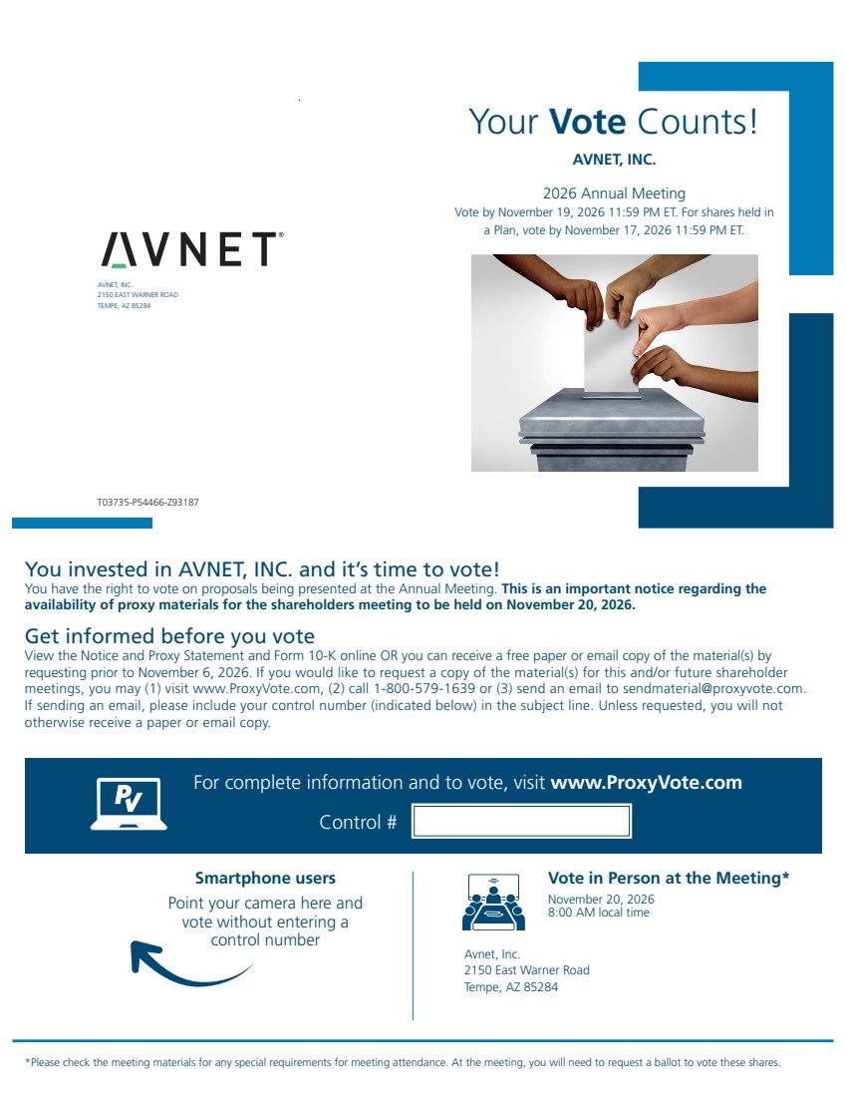 | Your Vote Counts! *Please check the meeting materials for any special requirements for meeting attendance. At the meeting, you will need to request a ballot to vote these shares. Smartphone users Point your camera here and vote without entering a control number For complete information and to vote, visit www.ProxyVote.com Control # T03735-P54466-Z93187 You invested in AVNET, INC. and it’s time to vote! You have the right to vote on proposals being presented at the Annual Meeting. This is an important notice regarding the availability of proxy materials for the shareholders meeting to be held on November 20, 2026. Get informed before you vote View the Notice and Proxy Statement and Form 10-K online OR you can receive a free paper or email copy of the material(s) by requesting prior to November 6, 2026. If you would like to request a copy of the material(s) for this and/or future shareholder meetings, you may (1) visit www.ProxyVote.com, (2) call 1-800-579-1639 or (3) send an email to sendmaterial@proxyvote.com. If sending an email, please include your control number (indicated below) in the subject line. Unless requested, you will not otherwise receive a paper or email copy. AVNET, INC. 2150 EAST WARNER ROAD TEMPE, AZ 85284 AVNET, INC. 2026 Annual Meeting Vote by November 19, 2026 11:59 PM ET. For shares held in a Plan, vote by November 17, 2026 11:59 PM ET. Vote in Person at the Meeting* November 20, 2026 8:00 AM local time Avnet, Inc. 2150 East Warner Road Tempe, AZ 85284
 | 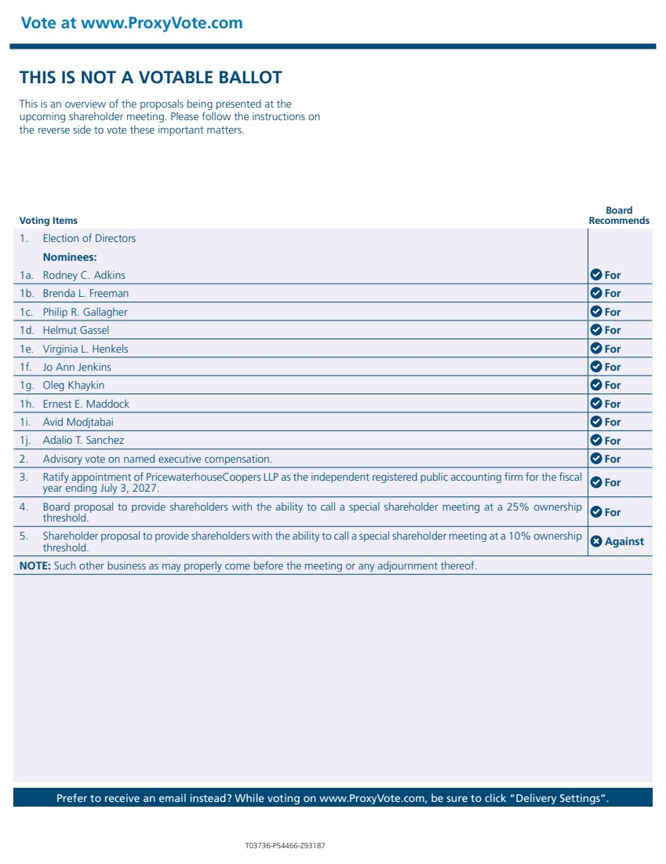 | Vote at www.ProxyVote.com Prefer to receive an email instead? While voting on www.ProxyVote.com, be sure to click “Delivery Settings”. T03736-P54466-Z93187 Voting Items Board Recommends THIS IS NOT A VOTABLE BALLOT This is an overview of the proposals being presented at the upcoming shareholder meeting. Please follow the instructions on the reverse side to vote these important matters. 1. Election of Directors Nominees: 1a. Rodney C. Adkins For 1b. Brenda L. Freeman For 1c. Philip R. Gallagher For 1d. Helmut Gassel For 1e. Virginia L. Henkels For 1f. Jo Ann Jenkins For 1g. Oleg Khaykin For 1h. Ernest E. Maddock For 1i. Avid Modjtabai For 1j. Adalio T. Sanchez For 2. Advisory vote on named executive compensation. For 3. Ratify appointment of PricewaterhouseCoopers LLP as the independent registered public accounting firm for the fiscal year ending July 3, 2027. For 4. Board proposal to provide shareholders with the ability to call a special shareholder meeting at a 25% ownership threshold. For 5. Shareholder proposal to provide shareholders with the ability to call a special shareholder meeting at a 10% ownership threshold. Against NOTE: Such other business as may properly come before the meeting or any adjournment thereof.

